**BWANDA ST. THERESA, NABBUNGA FOE AND MK SCHOOL – JOINT EXAMINATIONS 2022.**

**INTEGRATED SCIENCE FOR PRIMARY SEVEN (2HRS 15MIN)**

Name: __________________________________________________EMIS No.___________

**Index Number: Signature:____________________**

|  |  |  |
| --- | --- | --- |
| **FOR EXAMINERS’ USE ONLY** | | |
| **Qn. No.** | **Marks** |  |
| 1-10 |  |  |
| 11-20 |  |  |
| 21-30 |  |  |
| 31-40 |  |  |
| 41-43 |  |  |
| 44-46 |  |  |
| 47-49 |  |  |
| 50-52 |  |  |
| 53-55 |  |  |
| **TOTAL** |  |  |

**Read the Following Instructions carefully:**

1. This paper has two sections **A** and **B**
2. **Answer all questions**. All answers to both sections A and B must be written in the spaces provided.
3. **All** answers must be written using a Blue or Black ball-point pen or ink.
4. Unnecessary changes of work may lead to loss of marks.
5. Any handwriting that cannot be read may lead to loss of marks.

Do not fill anything in the boxes indicated; **“For Examiners’ Use Only”**.

**Turn Over**

**Section A:**

1. Name the human body organ used sight.  
   ___________________________________________________________________________
2. Give any one cause of dehydration.  
   ___________________________________________________________________________
3. Where dies fertilization take place in a flower?  
   ___________________________________________________________________________
4. Why are mineral salts absorbed without being digested?  
   ___________________________________________________________________________
5. How does a leguminous plant form plant proteins?  
   ___________________________________________________________________________
6. 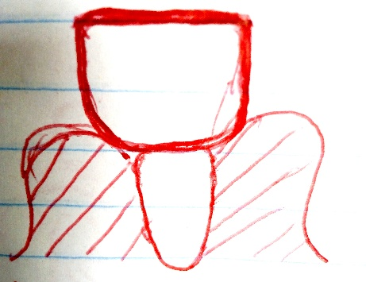Mention any one use of limbs to a monkey.  
   ___________________________________________________________________________  
   *The diagram below shows a type of tooth. Use it to answer questions 7 and 8*
7. How is the tooth above adapted to its function?  
   ___________________________________________________________________________
8. Give any one way a P.4 child can care for the tooth above.  
   ___________________________________________________________________________
9. Write CDD in full.  
   ___________________________________________________________________________
10. Mention the special organs found on the abdomen of spider which are used to spin silk.  
    ___________________________________________________________________________
11. What are incandescent objects?  
    ___________________________________________________________________________  
    ___________________________________________________________________________
12. 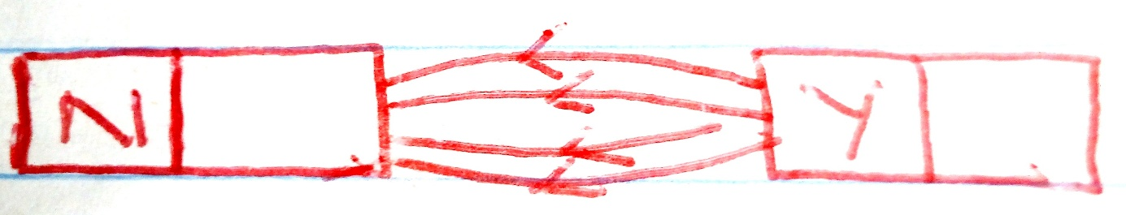Give any o ne example of a chemical change.  
    ___________________________________________________________________________  
    The diagram below shows magnets. Use it to answer questions 13 and 14
13. Name the magnetic pole marked Y  
    ___________________________________________________________________________
14. State any one way in which magnets can be destroyed.  
    ___________________________________________________________________________
15. Write any one SOP that helps to control the spread of diarrhoea diseases.  
    ___________________________________________________________________________
16. Which sense helps us to know the presence of sugar in tea?  
    ___________________________________________________________________________
17. A stone and a piece of paper were thrown up in the air. A stone reached the ground first. Why do you think the piece of paper reached the ground last?  
    ___________________________________________________________________________

___________________________________________________________________________

1. How is sound stored on CDs? ___________________________________________________________________________
2. 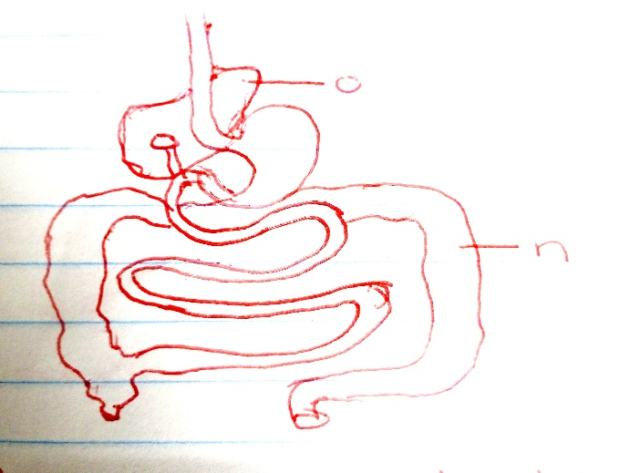Name that germ that causes sleeping sickness.  
   ___________________________________________________________________________  
   *The diagram below shows parts of a digestive system. Use it to answer questions 20 and 21*
3. Name the part marked ‘N’.  
   ___________________________________________________________________________
4. Where is the digestive juice produced by part ‘O’ stored?  
   ___________________________________________________________________________
5. Which method is used to find the volume of an irregular object?  
   ___________________________________________________________________________
6. Why is the pulp cavity the most sensitive part of a tooth?  
   ___________________________________________________________________________
7. Give the method of harvesting trees that allows a shoot system to grow from a stump.  
   ___________________________________________________________________________
8. What is food insecurity?  
   ___________________________________________________________________________

___________________________________________________________________________

1. Which name is given to structures that balance an insect during flight?   
   ___________________________________________________________________________
2. In the space below, draw the garden tool used for transplanting.
3. Why are the human eyes able to see clearly in broad light than in darkness at night?  
   ___________________________________________________________________________  
   ___________________________________________________________________________
4. 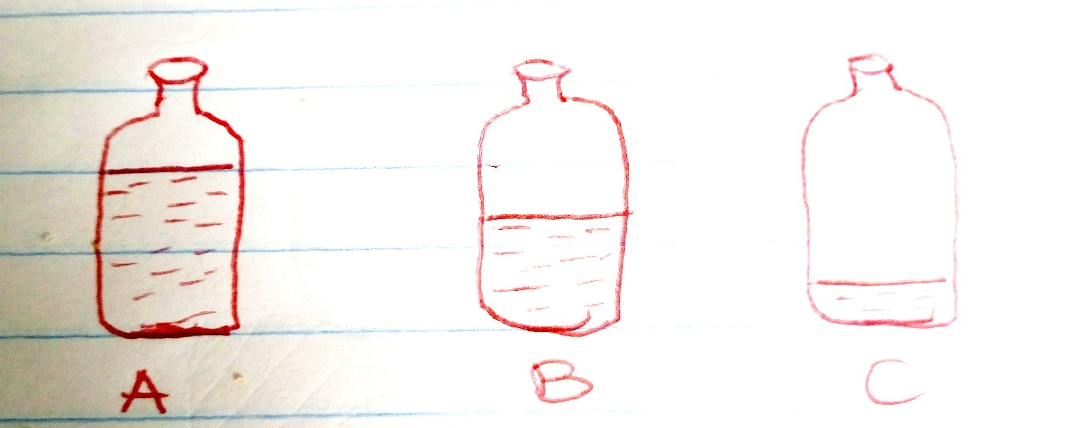Name the exotic breed of sheep kept for wool production.  
   ___________________________________________________________________________  
   The bottles below were filled with water at different levels to experiment pitch of sound. Use it to answer questions 30 and 31.
5. Which of the bottles above produced sound of a highest pitch?  
   ___________________________________________________________________________
6. Give a reason to support your answer above.  
   ___________________________________________________________________________
7. Write any o ne element of weather.  
   ___________________________________________________________________________
8. Why is it advisable to wear white clothes during hot days?  
   ___________________________________________________________________________

___________________________________________________________________________

1. What attracts moths to visit flowers at night?  
   ___________________________________________________________________________
2. Name the type of leaf venation common in cereal crops.  
   ___________________________________________________________________________
3. Give the force that makes things weigh less when put in water.  
   ___________________________________________________________________________
4. Use the list below to form a food chain.  
   ladybug, plant sap, birds, aphids  
   ___________________________________________________________________________
5. Give a plant process similar to sweating in animals.  
   ___________________________________________________________________________
6. How is the nose adapted to its function of smelling?  
   ___________________________________________________________________________
7. How is a fuse similar to a switch in the way they function?  
   ___________________________________________________________________________  
    **SECTION B:**
8. a) Which gas is needed in the process of making charcoal?  
   ___________________________________________________________________________  
   b) State one way we can reduce the amount of charcoal used for cooking.  
   ___________________________________________________________________________

c) Give one reason why you would discourage the use the charcoal in your area.  
___________________________________________________________________________  
d) Apart from charcoal, give any other wood fuel.  
___________________________________________________________________________

1. 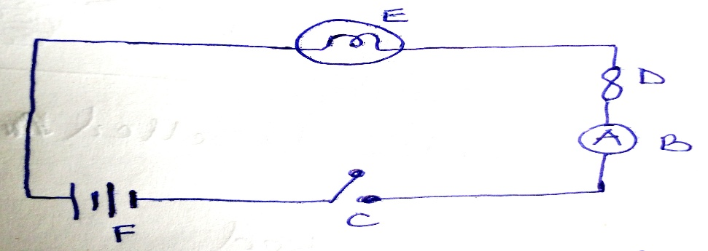The diagram below is of an electric circuit. Use it to answer the following questions.  
     
     
     
     
     
     
     
   a) Name parts labeled B and F  
     
   B______________________________________ F ________________________________  
   b) Which energy change takes place at **E** when **C** is closed?  
   ___________________________________________________________________________  
   c) State one factor that may stop part E from giving out light when **C** is closed.  
   ___________________________________________________________________________
2. 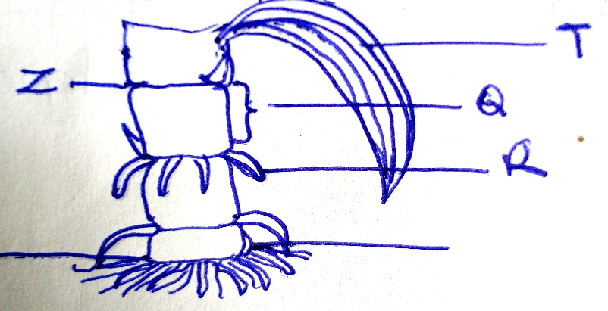a) Study the part of a plant below and use it to answer the questions that follow.

a) Name the part marked “**Z”**.  
___________________________________________________________________________  
b) Why do structure marked “ **R ”** develop during flowering?  
___________________________________________________________________________  
c) Which type of germination does the plant above undergo?  
___________________________________________________________________________  
d) Give one example of a plant with fibrous root system apart from maize.  
___________________________________________________________________________

1. a) What is puberty?  
   ____________________________________________________________________________________________________________________________________________________________  
   b) Give one secondary sex change that happens only in girls during adolescence.  
   ___________________________________________________________________________  
   c) Mention any two PIASCY message that safe guards girls against HIV/AIDS.  
   i) ___________________________________________________________________________  
   ii) ___________________________________________________________________________
2. 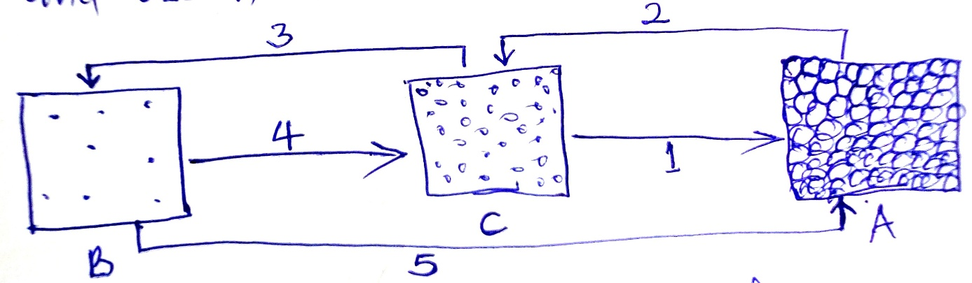a) The diagram below shows changes in states of matter. Study and use it to answer the questions that follow.  
     
     
     
     
     
     
     
     
   a) Identify the state of matter labeled **“C”**___________________________________________________________________________  
   b) Name the process marked  
   1. ___________________________________________________________________________  
   5. ___________________________________________________________________________  
   c) What form of energy changes the state of matter **C** to **B** ?  
   ___________________________________________________________________________
3. a) Write down any two ways in which plants benefit animals.  
   i) ___________________________________________________________________________  
   ii) ___________________________________________________________________________  
   b) Give any two ways in which living things depend on non-living things.  
   i) ___________________________________________________________________________  
   ii) ___________________________________________________________________________
4. Identify the human body organ where each of the following takes place.  
   a) Blood gets oxygen while carbon dioxide is removed.  
   ___________________________________________________________________________b) Filtration of blood.  
   ___________________________________________________________________________  
   c) Manufacture of vitamin D with the help of the sun ultra violet rays.  
   ___________________________________________________________________________  
   d) Storage of vitamins and mineral salts.  
   ___________________________________________________________________________
5. a) Name any one body organ affected by cigarette smoking.  
   ___________________________________________________________________________   
   b) Give any one reason why people smoke.  
   ___________________________________________________________________________  
   c) Why do active smokers remove ash from a cigarette when smoking?  
   ___________________________________________________________________________  
   d) Identify one danger of smoking besides causing lung cancer.  
   ___________________________________________________________________________
6. a) State the main duty of a queen bee in a hive.  
   ___________________________________________________________________________  
   b) State one reason why a drone bee is not commonly found in a bee hive.  
   ___________________________________________________________________________  
   c) How is a queen excluder useful in a bee hive?  
   ___________________________________________________________________________  
   d) Why is it possible to keep honey for many months without it going bad?  
   ______________________________________________________________________________________________________________________________________________________
7. 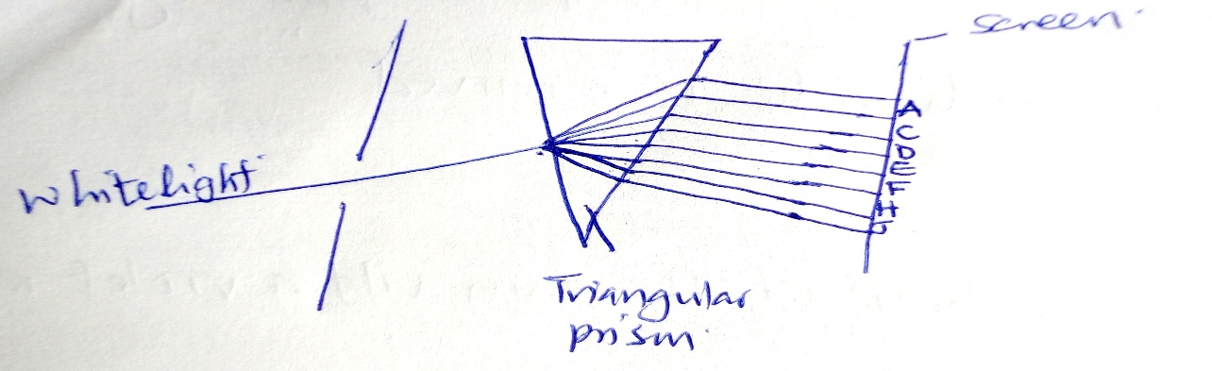Use the diagram below to answer questions.  
     
     
     
     
     
     
     
     
   a) Name colours marked **A** and **H**  
   A____________________________________________________  
   H____________________________________________________  
   b) Why do colours bend at different angles?  
   ____________________________________________________________________________________________________________________________________________________________  
   c) State one effect of refraction of light.  
   ______________________________________________________________________________
8. 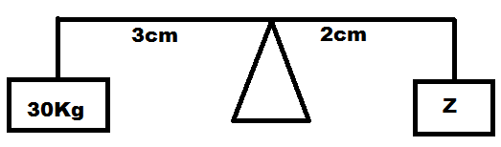a) What is a simple machine?  
   ____________________________________________________________________________________________________________________________________________________________  
   b) Give one advantage of machines.  
   ___________________________________________________________________________  
   c) Find the weight at “**Z”**
9. a) Mention two methods of grazing cattle.  
   i) ___________________________________________________________________________  
   ii) ___________________________________________________________________________  
   b) Give one reason why farmers castrate their animals.  
   ___________________________________________________________________________  
   c) Mention one method farmers use to identify their cattle.  
   ___________________________________________________________________________
10. a) Which name is given to a female rabbit?  
    ___________________________________________________________________________  
      
      
      
    b) Give any one reason why a rabbit hutch is raised above the ground.  
    ______________________________________________________________________________________________________________________________________________________  
      
    c) State two reason why a wire mesh is used in building a rabbit hutch.   
    i) ___________________________________________________________________________  
    ii) ___________________________________________________________________________
11. Match the diseases in list A to the animals they attack in list B below correctly.  
    **List A List B**  
    - New castle disease Cattle  
    - African swin fever Mad dogs  
    - Rabies Poultry  
    - Rider pest Pigs   
      
    i) New Castle disease ____________________________________________________  
    ii) African swin fever ____________________________________________________  
    iii) Rabies ____________________________________________________  
    iv) Rider pest ____________________________________________________
12. Write down two methods used to get clean and safe drinking water.  
    i) ___________________________________________________________________________  
    ii) ___________________________________________________________________________

b) Mention any two ways clean water can be re-contaminated.  
i) ___________________________________________________________________________  
ii) ___________________________________________________________________________  
  
  
  
  
  
  
 **BWANDA ST. THERESA, NABBUNGA FOE AND MK SCHOOL – JOINT EXAMINATIONS 2022.**

**ENGLISH FOR PRIMARY SEVEN (2HRS 15MIN)**

Name: ________________________________________________EMIS No.___________

**Index Number: Signature:____________________**

|  |  |  |
| --- | --- | --- |
| **FOR EXAMINERS’ USE ONLY** | | |
| **Qn. No.** | **Marks** |  |
| 1-10 |  |  |
| 11-20 |  |  |
| 21-30 |  |  |
| 31-40 |  |  |
| 41-43 |  |  |
| 44-46 |  |  |
| 47-49 |  |  |
| 50-52 |  |  |
| 53-55 |  |  |
| **TOTAL** |  |  |

**Read the Following Instructions carefully:**

1. This paper has two sections **A** and **B**
2. **Answer all questions**. All answers to both sections A and B must be written in the spaces provided.
3. **All** answers must be written using a Blue or Black ball-point pen or ink.
4. Unnecessary changes of work may lead to loss of marks.
5. Any handwriting that cannot be read may lead to loss of marks.

Do not fill anything in the boxes indicated; **“For Examiners’ Use Only”**.

**Turn Over**

**SECTION: A.**

**Sub-Section I**

***In each of the questions 1 – 5, fill in the blank spaces with a suitable word.***

1. To __________________________does this answer sheet belongs?
2. Father read __________________article about increased bribery in Uganda in The Daily Monitor.
3. Mrs. Apio was the master of _____________________on my uncle’s wedding.
4. Scarcely had the minister died __________________the mourners flocked his home.
5. The lady ________________________________ I told you is our class teacher.

***In each of the questions 6 – 15, use the correct form of the word given in the brackets to complete the sentence.***

1. Tendo saw a puppy feeding ___________________________________.(it)
2. The detective stopped the ______________________________of Mr. Tomusange towards Jane’s death. (suspect)
3. We would __________________________________in our exams if we revised seriously. (success)
4. The orphans _______________________________looked at their father’s corpse. (worry)
5. He looks forward to ___________________________________a letter to his penpal in London. (write)
6. The timekeeper had ______________________the bell before the usual time. (ring)
7. Of all vehicles, bikes move the ________________________in traffic jams. (well)
8. I often take my car for ______________________________on weekends. (maintain)
9. Apart from the ________________________actress, who else needed a costume? (forty)
10. The farmers _____________________terracing their land to control soil erosion. (to be)

***In questions 16 – 17, arrange the given words alphabetically.***

1. choose, caught, catch, cat

________________________________________________________________________

1. routine, fauna, sugar daddy, letter

________________________________________________________________________

***In each of the questions 18 – 19, use the given word in a sentence to show that you know the difference in their meaning.***

1. our

___________________________________________________________________

1. hour

___________________________________________________________________ ***In questions 20 – 21, write giving the plural form of the underlined word.***

1. She is doing her examination quietly.

___________________________________________________________________

1. Does your father keep s sheep on his farm?

___________________________________________________________________ ***In each of the questions 22 – 24, give the opposite of the underlined word.***

1. The acquittal of Mr. Guweddemu was realized in court.

___________________________________________________________________

1. Olga’s work is legible enough for me to read.

___________________________________________________________________

1. Married people are not respected in society.

___________________________________________________________________ ***In each of the questions 25 – 26, rewrite the sentences giving a single word for the underlined group of words.***

1. The butcher slaughtered the cow without mercy.

___________________________________________________________________

1. The pupils doing the examination are many.

__________________________________________________________________ ***In questions 27 – 28, write the short forms of the given words.***

1. for instance:________________________________________________________ ________________________________________________________________________
2. cannot: _______________________________________________________________________

***For questions 29 and 30, rearrange the words to form correct sentences.***

1. Sinning causes after suspicion Shivering.

___________________________________________________________________

1. travel Mbarara you by Did to bus?

___________________________________________________________________

**In each of the questions 31 – 50, rewrite the sentences as instructed in the brackets.**

1. We shall go to the zoo. We shall go to the National Park. *(Join using: ………..either……or……….)*

____________________________________________________________________________________________________________________________________________________________

1. Jonah wants to send an e-mail to his penpal. He will go to the internet café. (Rewrite as one sentence using: …………….since………..)

______________________________________________________________________________________________________________________________________

1. The man was a Ghanaian. We travelled with him in the train. (Join as one sentence using ……………..whom……..)

______________________________________________________________________________________________________________________________________

1. That young girl needn’t have dropped out of school. (Rewrite using……….necessary…….)

______________________________________________________________________________________________________________________________________

1. Mr. Akiiki was very popular but few people buried him. (Rewrite and use: ………..however…….)

_______________________________________________________________________________________________________________________________________________________

1. A volleyball team consists of seven players. (Rewrite and use: ……comprise……….)

___________________________________________________________________________________________________________________________________________________________

1. The bride has a golden gown, ________________________________?(Supply a suitable question tag)

__________________________________________________________________

1. Nobody is more handsome than Elvis in this school. (Begin: Elvis……….)

__________________________________________________________________________________________________________________________________________________________

1. P.7 candidates of this year will perform excellently if their teachers geode them. *(Rewrite and use: unless……………)*

______________________________________________________________________________________________________________________________________

1. This nice car belongs to Zedde. (Form a question to the above response)

_____________________________________________________________________________

1. One’s mother will come tomorrow. (Begin: A mother………………..)

___________________________________________________________________

1. As soon as the monkey saw us, it started chattering. (Begin: No sooner…….)

____________________________________________________________________________________________________________________________________________________________

1. True Christians say prayers. They leave their beds in the morning. (Use: Before……)

____________________________________________________________________________________________________________________________________________________________

1. Ceaser started baking cakes in the afternoon. It is now evening and he is still baking them. (Use: ………………..since………….)

______________________________________________________________________________________________________________________________________

1. It is a long way from Uganda to Kenya. (Rewrite using: ………far……….)

___________________________________________________________________

1. There is soil erosion on the land. The farmer did not terraces. (Join using: ………would not have ……………)

_________________________________________________________________________________________________________________________________________________________

1. Nagasha knits sweaters. Nagasha knits baby stockings. (Begin: Not only….)

_________________________________________________________________________________________________________________________________________________________

1. The English exam is very easy. Each learner will pass it highly. (Join using: ….enough……)

___________________________________________________________________________________________________________________________________________________________

1. I intend to become a politician in future. (Begin: My…………..)

____________________________________________________________________________

1. The New Vision has a very intelligent editor. (Begin: What ……….!)

_____________________________________________________________________________  
______________________________________________________________________________

**SECTION B.**

1. ***Read the passage below and answer the questions that follow in full sentences.***

Heavy traffic, air pollution and litter are among the most serious problems modern cities face nowadays. Ours is exceptional. What can we do then to make our city more pleasing to its residents?

First of all, it would be a good idea to encourage people to use public transport instead of their cars, especially while community to work. The result would be fewer cars on the roads, and therefore less traffic jam.

Secondly, steps should be taken in order to solve the problem of air pollution. The situation could be improved if factories were moved out of the city. If this happened the air would not be polluted.

Finally, efforts should be to make our city a cleaner and healthier place to live. A useful suggestion would be to put more litter bins in the streets. If this was done, people would stop dropping their rubbish on the ground and our city would be cleaner.

There are many ways to make our city a better place to live. Adopting some of these measures would definitely result into better living conditions for everyone.

**Questions:**

1. What are some of the problems that face modern cities nowadays?

____________________________________________________________________________________________________________________________________________________________

1. Which kind of transport should people be encouraged to use?

___________________________________________________________________

1. What could happen if factories were moved out of the city?

______________________________________________________________________________________________________________________________________________________

1. Why should more litter bins be put in the city?

______________________________________________________________________________________________________________________________________________________

1. Why should people use the kind of transport mentioned in the passage?

________________________________________________________________________

1. Give the opposite of the word “public”.

_________________________________________________________________________

1. Give another word or a group of words to mean the same as,
2. residents _______________________________________________________
3. litter ___________________________________________________________
4. What advice did the writer give in order to have a better city to live according to the passage?

___________________________________________________________________________________________________________________________________________________________

1. Suggest a suitable title for the passage

______________________________________________________________________________

1. ***Read the notice below answer questions that follow in full sentences.***

PRIVATE ENGLISH LESSONS

An experiences and qualified teacher is offering private lessons in English.

Lessons are in two phases

Saturday – 8:00a.m – 12:00p.m

Sunday – 2:00p.m – 4:00p.m

Venue – Tgaba Kindgdom Hall

Areas of attention: grammer, composition and literature

Classes of interest – Primary 5, 6 and 7

Free skills in speaking are offered

Soya Bushe – 0775970047

(For more information)

10.06.2017

**Questions:**

1. What is the information about?

__________________________________________________________________________________________________________________________________________________________

1. What kind of teacher is offering this service?

____________________________________________________________________________

1. At what time do lessons begin on Saturday?

____________________________________________________________________________

1. On which days are lessons conducted?

_____________________________________________________________________________

1. What is the venue of the exercise?

______________________________________________________________________________

1. Name any two areas to be taught by the teacher

___________________________________________________________________

1. If you have a child in Primary Three, will you benefit from the program?

______________________________________________________________________________________________________________________________________

1. When was this information written?

___________________________________________________________________

1. How can one get more information about this activity?

______________________________________________________________________________

1. How long will lessons last on Sunday?

______________________________________________________________________________________________________________________________________

1. Read the poem below and answer questions that follow in full sentences.

God will make you the head

If you do all your best

Believe in yourself

He will direct you

Pray to God all the time

And He will give you courage

He has shown us the way

Till today

Pray always to start the day

God helps those who help themselves

Don’t despair, He will keep you too

Seek wisdom, you will shine

Refrain from bad company

Keep good company

Say no to all temptations

That is the way God will help you

Shifrah P.7S

Questions

1. What is the above poem about?

___________________________________________________________________

1. How many stanzas has the poem?

______________________________________________________________________________________________________________________________________

1. What will God do if you do all your best?

___________________________________________________________________

1. What has God shown us?

______________________________________________________________________________________________________________________________________

1. Which stanza talks about wisdom?

___________________________________________________________________

1. According to this poem, what should one say no to?

______________________________________________________________________________

1. By whom was the poem written?

________________________________________________________________

1. Why do you think the poet tells us to refrain from bad companies?

___________________________________________________________________________________________________________________________________________________________

1. How many verses does stanza four have?

___________________________________________________________________________

1. Give another word to mean the same as “refrain” according to the poem.

___________________________________________________________________________

1. ***The story below is in a wrong order. Write it correctly to form a story.***
2. It was about letter writing.
3. As soon as the headmaster left the classroom, the new teacher started the lesson.
4. One day, the headmaster entered our classroom with a lady.
5. He said she was Mrs. Opio Edith.
6. He greeted us and asked us to take our seats.
7. We all stood up as soon as we saw them.
8. She explained everything clearly.
9. We enjoyed ourselves throughout the lesson.
10. Immediately after the introduction, the headmaster walked back to his office.
11. After we had sat, he introduced the lady as our new teacher of English.

______________________________________________________________________________________________________________________________________________________________________________________________________________________________________________________________________________________________________________________________________________________________________________________________________________________________________________________________________________________________________________________________________________________________________________________________________________________________________________________________________________________________________________________________________________________________________________________________________________________

1. ***Imagine you have completed your P.L.E and you are in your vacation. You read the Monitor Newspaper about Satelite Computer Services. They offer computer training on weekends only. Write a letter to the Director Satelite Computer Services, P.O. Box 469, Luwum Street.***

***Ask him to admit you as one of his students for two weeks. Use your home address.***

______________________________________________________________________________________________________________________________________________________________________________________________________________________________________________________________________________________________________________________________________________________________________________________________________________________________________________________________________________________________________________________________________________________________________________________________________________________________________________________________________________________________________________________________________________________________________________________________________________________________________________________________________________________________________________________________________________________________________________________________________________________________________________________________________________________________________________________________________________________________________________

**BWANDA ST. THERESA, NABBUNGA FOE AND MK SCHOOL – JOINT EXAMINATIONS 2022.**

**MATHEMATICS FOR PRIMARY SEVEN (2HRS 30MIN)**

Name: ________________________________________________EMIS No.___________ **Index Number: Signature:____________________**

|  |  |  |
| --- | --- | --- |
| **FOR EXAMINERS’ USE ONLY** | | |
| **Qn. No.** | **Marks** |  |
| 1-10 |  |  |
| 11-20 |  |  |
| 21-30 |  |  |
| 31-40 |  |  |
| 41-43 |  |  |
| 44-46 |  |  |
| 47-49 |  |  |
| 50-52 |  |  |
| 53-55 |  |  |
| **TOTAL** |  |  |

**Read the Following Instructions carefully:**

1. This paper has two sections **A** and **B**
2. **Answer all questions**. All answers to both sections A and B must be written in the spaces provided.
3. **All** answers must be written using a Blue or Black ball-point pen or ink.
4. Unnecessary changes of work may lead to loss of marks.
5. Any handwriting that cannot be read may lead to loss of marks.

Do not fill anything in the boxes indicated; **“For Examiners’ Use Only”**.

**Turn Over**

|  |  |  |  |
| --- | --- | --- | --- |
| **SECTION: A** | | | |
| 1. | Multiply: 106 x 4 | 2. | Given that set N = all prime numbers less than 11 , Find n ( N ) |
| 3. | Find the value of 24 + 30 | 4. | Write the single number from the scientific notation number, 2.4 x 10-2 |
| 5. | Divide | 6. | Juma has a bundle of five thousand shillings notes numbered consecutively from AP534201 to AP534300. How much money does he have? |
| 7. | Find the distance around the figure  **0**  28cm | | |
|  |  |  |  |
| 8. | Simplify: -4++7 | 9. | Find the average of |
| 10. | Use the diagram below to work out the value of P. | | |
| 11. | Solve: | 12. | The time on a 24-hour clock is 1342hrs. What time will it be on a 12hour clock? |
| 13. | Ruth bought a dress at shs. 100,000 and sold it at shs. 125,000. What was his percentage profit? | 14. | On the diagram below, describe the shaded part. |
| 15. | Given that 34t = 112four, find the value of t. | | |
| 16. | Using the diagram below, find the bearing of town **P** from town **Q** | | |
| 17. | Solve the inequality: -4 > -1 > 2 | 18. | Jane had a string measuring 1.2m. How many pieces will she get from it if she’s to cut it into pieces of 12cm longer? |
| 19. | Subtract from | 20. | Show the lines of folding symmetry on the figure below; |
| **SECTION B:** | | | |
| 21. | Study the abacus below and use it to answer the questions;   1. Write the number on the abacus in words. (2mks) | | |
| b) | Find the value of the digit in the place value of hundreds. (1mk) | c) | Round off the above number to the nearest tens. (2mks) |
| 22. | 1. Solve for P. 2p x (3mks) | b) | Using a factor tree, prime factorise 72 and represent the factors in set notation (2mks) |
| 23. | Study the Venn diagram below and use it to answer the questions.  **a)** If = 31 pupils, find the value   of  *(2mks)* | | |
|  | 1. Find the chance of selecting a pupil at random who likes both subjects. (3mks) | | |
| 24. | The bicycle wheel of a radius 35cm, moved from Villa Maria to Masaka at a speed of 22km/h in 4hours. How many revolutions will the bicycle make? | | |
| 25. | Below is a right angled trapezium, find its area. (5mks) | | |
| 26. | By selling a radio at shs. 180,000 a trader makes a loss of 10%. How much would he sell it in order to make a gain of 20%? (5mks) | | |
| 27. | ***The table below shows marks scored in mock examinations.***   |  |  |  |  |  | | --- | --- | --- | --- | --- | | **Frequency** | 4 | 2 | 1 | 3 | | **Marks** | 60 | 80 | 70 | 90 |  1. How many pupils sat for examinations? (1mk) | | |
|  | b) Calculate the range score. |  | c) How many pupils scored the average mark? (3mks) |
| 28. | Eyvet had a note of twenty thousand shillings and used it to purchase the following items.  - 10 pencils at shs 500 for every two pencils   * 3kgs of salt at shs 1500 @kg * 500ml of milk at shs 3000 per litre * ½ kg of meat at shs 4500   a) Find the total expenditure. (4mks)    b) Calculate the change after purchasing. (1mk) | | |
| 29. | Study the figure below and use it to answer the questions.  a) Find the value of . (3mks)         b) Workout the value of (2mks)  **0** | | |
| 30. | The mother is 20years older than her daughter. In 5years time the mother will be twice as old as her daughter.  a) How old is the mother? (3mks) | b) | How old will be the daughter? (2mks) |
| 31. | Use the number line below to answer the questions.    a) List integers for: a =    b =    c =    b) Suggest the mathematical statement from the number line above. (2mks) | | |
| 32. | Below is a table showing the movement of Global coaches from Mbarara to Kampala.   |  |  |  | | --- | --- | --- | | **Town** | **Arrival** | **Departure** | | Mbarara |  | 9:00am | | Sanga | 9:45am | 10:00am | | Lyantonde | 11:15am | 11:30am | | Masaka | 12:00noon | 12:20pm | | Kampala | 1:30pm |  |   a) If Kampala is about 252km from Mbarara, calculate the average speed from the bus for the whole journey. (1mk)  b) Convert the arrival time of the bus at Kampala in 24hour system. (1mk)  c) For how long did the bus stay at Sanga? (2mk) | | |
|  |  |  |  |

**END**

**BWANDA ST. THERESA, NABBUNGA FOE AND MK SCHOOL – JOINT EXAMINATIONS 2022.**

**INTEGRATED SOCIAL STUDIES AND R.E FOR PRIMARY SEVEN (2HRS 15MIN)**

Name: ________________________________________________EMIS No.___________ **Index Number: Signature:____________________**

|  |  |  |
| --- | --- | --- |
| **FOR EXAMINERS’ USE ONLY** | | |
| **Qn. No.** | **Marks** |  |
| 1-10 |  |  |
| 11-20 |  |  |
| 21-30 |  |  |
| 31-40 |  |  |
| 41-43 |  |  |
| 44-46 |  |  |
| 47-49 |  |  |
| 50-52 |  |  |
| 53-55 |  |  |
| **TOTAL** |  |  |

**Read the Following Instructions carefully:**

1. This paper has two sections **A** and **B**
2. **Answer all questions**. All answers to both sections A and B must be written in the spaces provided.
3. **All** answers must be written using a Blue or Black ball-point pen or ink.
4. Unnecessary changes of work may lead to loss of marks.
5. Any handwriting that cannot be read may lead to loss of marks.

Do not fill anything in the boxes indicated; **“For Examiners’ Use Only”**.

**Turn Over**

**Section A:**

1. Name the map element that helps a map reader to identify symbols.  
   ____________________________________________________________________________
2. Give any one function of a post office in your area.  
   ____________________________________________________________________________
3. What is the point between **R** and **S** on the compass rose below;

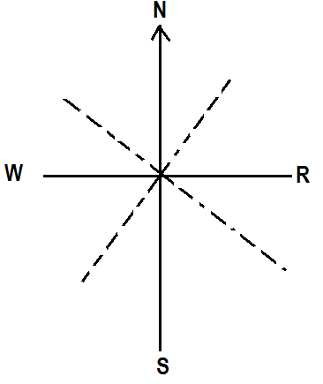

1. Why do deciduous trees in Tropic climate region have thorny stems and branches?  
   _________________________________________________________________________________________________________________________________________________________
2. Give an evidence to show that the Portuguese once lived at the coast of East Africa.  
   ____________________________________________________________________________
3. Write down one way how regional economic groupings like SADC have fought smuggling in their member states.  
   ____________________________________________________________________________
4. Mention any one economic activity that can bring about climate change in an area.  
   ____________________________________________________________________________
5. Give one group of people who are approved by the Legislature in Uganda.  
   ____________________________________________________________________________
6. Which tax is charged on imported goods in Uganda?  
   ____________________________________________________________________________
7. How does industrialization bring about rapid population growth in an area?  
   ________________________________________________________________________________________________________________________________________________________
8. Give any one economic importance of lake Katwe to the people around it.  
   ____________________________________________________________________________
9. Name the political head of a constituency.  
   ____________________________________________________________________________
10. Suggest one social importance of keeping cattle.  
    ____________________________________________________________________________
11. In which one way does tourism promote craft industry?  
    ____________________________________________________________________________
12. Give one role played by a midwife in a community.  
    ____________________________________________________________________________

*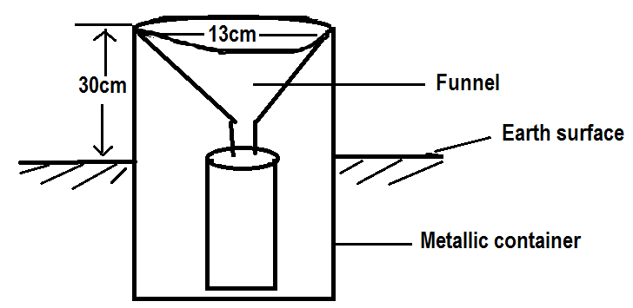Use the diagram below to answer the question that follows.*

1. Why the above instrument is placed 30cm above the ground?  
   ________________________________________________________________________________________________________________________________________________________
2. Give the importance of a funnel on the above weather instrument.  
   ____________________________________________________________________________
3. Use letter **W** to mark the measuring cylinder.  
   ____________________________________________________________________________
4. Mention the law making organ of the East African Community.  
   ____________________________________________________________________________
5. Write one sector / service in Uganda that is decentralized.  
   ____________________________________________________________________________
6. State any one role played by the chartered companies in the colonization of East African countries.  
   ____________________________________________________________________________
7. Give one method of mining used to extract natural gas and petroleum in the sea and on land.  
   ____________________________________________________________________________
8. Apart from oases, name any other tourist attraction found in the Sahara desert.  
   ____________________________________________________________________________
9. Write down any one way people protect their property from danger.  
   ____________________________________________________________________________
10. How did the 1967 constitution affect the cultural institutions in Uganda?  
    ____________________________________________________________________________
11. What role does Lake Tana play towards the irrigation farming at Gezira in Sudan?  
    ____________________________________________________________________________
12. Suggest one way Rwanda has benefited from hosting the 2022 Common Wealth Heads of Government Meeting (CHOGM).  
    ____________________________________________________________________________
13. What role was played by the Late Bishop Desmond Tutu in ending the apartheid rule in South Africa?  
    ____________________________________________________________________________
14. What title is given to the presidential representative in a city?  
    ____________________________________________________________________________
15. Which waterfalls are associated with the death of Dr. Mungo Park in West Africa?  
    ____________________________________________________________________________
16. Write UNBS in full.  
    ____________________________________________________________________________
17. What name was given to the land of the black people along the coast of East Africa?  
    ____________________________________________________________________________
18. What type of wood is got from trees in the Mediterranean vegetation?  
    ____________________________________________________________________________
19. Name the last vegetation zone that grows on a mountain.  
    ____________________________________________________________________________
20. In which way is a low population a disadvantage in a country?  
    ____________________________________________________________________________  
      
    ***For questions 36 to 40 answer Either Christianity or Islamic question but not both.***
21. **Either:** Which parable teaches Christians to help the needy people?  
    ____________________________________________________________________________  
    **Or:** Which pillar in Islam teaches Muslims to help the needy people?  
    ____________________________________________________________________________
22. **Either:** What marks the beginning of Lent in Christianity?  
    ____________________________________________________________________________  
    **Or:** What marks the beginning of Saum in Islam?  
    ____________________________________________________________________________
23. **Both:** In which way are Angels similar to Prophets?  
    ________________________________________________________________________________________________________________________________________________________
24. **Either:** Give one act of charity among the Christians today.  
    ____________________________________________________________________________  
    **Or:** State one act of charity among Muslims today.  
    ____________________________________________________________________________
25. **Either:** When does a Christian ask for forgiveness from God?  
    ________________________________________________________________________________________________________________________________________________________  
    **Or:** When does a Muslim ask for forgiveness from Allah?  
    ____________________________________________________________________________  
      
    **SECTION B:**
26. **a)** Mention the system of government where political parties compete to gain control of the government.  
    ____________________________________________________________________________  
      
    b) Give any two advantages of the system named in (a) above.  
    i)__________________________________________________________________________  
    ii)__________________________________________________________________________  
    c) State any one negative effect of the above names system.  
    ____________________________________________________________________________
27. a) Which organ of the African Union is responsible for the day to day activities?  
    ____________________________________________________________________________  
    b) Give any two achievements of the African Union.  
    i) ____________________________________________________________________________  
    ii) ___________________________________________________________________________  
    C) State any one problem faced by the African Union.  
    ____________________________________________________________________________
28. 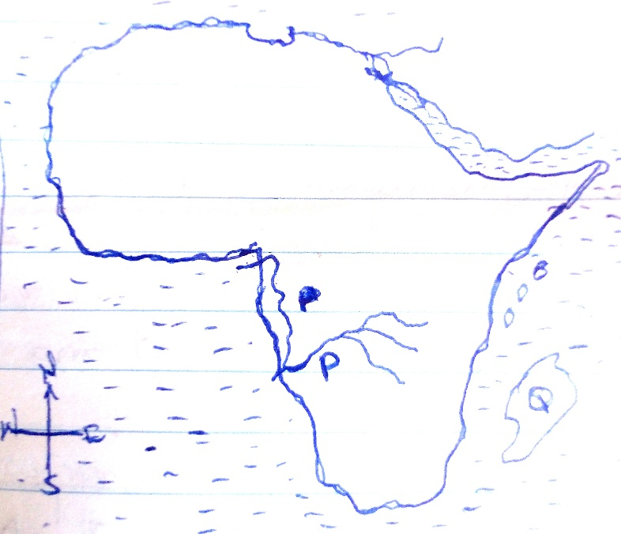a)Study the sketch map of Africa below and answer the questions that follows.  
      
      
      
      
      
      
      
      
      
      
      
      
      
      
      
    a) Name the Island country marked Q  
    ____________________________________________________________________________  
    b) Why does river marked P flow west wards?  
    ________________________________________________________________________________________________________________________________________________________  
    c) Gove o ne way in which the African continent is different from Europe. ________________________________________________________________________________________________________________________________________________________  
    d) Use a pen and a ruler to draw a prime meridian line on the map.
29. a) State any two major rivers in Africa which end in estuaries.  
    i) ____________________________________________________________________________  
    ii) ___________________________________________________________________________  
    b) In which two ways can rivers be used for development?  
    i) ____________________________________________________________________________  
    ii) __________________________________________________________________________
30. a) What term refers to the period of one year between one budget reading and another?  
    ____________________________________________________________________________  
    b) Name the main source of government revenue.  
    ____________________________________________________________________________  
    c) State two ways the country can improve on her income.  
    i) ____________________________________________________________________________  
    ii) __________________________________________________________________________\
31. a) Name the assembly that was introduced by colonialists in Uganda that brought unequal representation to Ugandans.  
    ____________________________________________________________________________  
    b) Give one reason why colonialists started the above assembly.  
    ____________________________________________________________________________  
    c) What name is given to the above assembly today?  
    ____________________________________________________________________________  
    d) Identify any special interest group represented in the current assembly of Uganda.  
    ____________________________________________________________________________
32. Study the climatic table below and answer the questions that follow;

|  |  |  |  |  |  |  |  |  |  |  |  |  |
| --- | --- | --- | --- | --- | --- | --- | --- | --- | --- | --- | --- | --- |
| ***Month*** | ***J*** | ***F*** | ***M*** | ***A*** | ***M*** | ***J*** | ***J*** | ***A*** | ***S*** | ***O*** | ***N*** | ***D*** |
| ***Temp (oC)*** | *23* | *23* | *23* | *22* | *22* | *22* | *21* | *22* | *22* | *22* | *22* | *23* |
| ***Rainfall (mm)*** | *40* | *70* | *150* | *230* | *205* | *115* | *56* | *80* | *195* | *225* | *150* | *50* |

a) What type of climate is shown on the table above?  
____________________________________________________________________________  
b) Name one African country which receives the type of climate mentioned in No. 47(a).  
____________________________________________________________________________  
c) Calculate the temperature range according to the table.  
  
  
  
  
  
d) Why is plantation farming the most suitable economic activity carried out in the area which experiences such climate?  
________________________________________________________________________________________________________________________________________________________

1. Match the following weather instruments to their uses correctly.  
     
   **Instruments Uses**Barometer Measures the speed of wind  
   Anemometer Measures humidity  
   Celometer Measures air pressure  
   Hygrometer Measures cloud cover  
     
   i) Barometer ________________________________________________________   
   ii) Anemometer ________________________________________________________   
   iii) Celometer ________________________________________________________   
   iv) Hygrometer _________________________________________________________
2. a) What is rural urban migration?  
   ______________________________________________________________________________________________________________________________________________________  
   b) Give any two causes of rural – urban migration.  
   i) ___________________________________________________________________________  
   ii) ___________________________________________________________________________  
   c) How can the government control rural –urban migration?  
   ______________________________________________________________________________________________________________________________________________________
3. a) Why is tourism referred to as an industry?  
   ______________________________________________________________________________________________________________________________________________________  
   b)Why are most game parks found in Savanna grassland? ______________________________________________________________________________________________________________________________________________________   
   c) Give two problems faced by game parks in Africa.  
   i)____________________________________________________________________________  
   ii)_________________________________________________________________________  
   ***For questions 52-55 answer either Christianity or Islam BUT not both on a number.***
4. a) Either: Who created heaven and earth?  
   ___________________________________________________________________________  
   b) Give one reason why God created Eve after Adam.  
   ___________________________________________________________________________  
   c) Name any two creatures that God put in the garden of Eden.  
   i) ___________________________________________________________________________  
   ii) ___________________________________________________________________________  
     
   Or: a) Who created heaven and earth?  
   ___________________________________________________________________________  
   b) How many days did Allah take to created the universe?  
   ___________________________________________________________________________  
   c) Mention any two creatures that Allah formed.  
   i) ___________________________________________________________________________  
   ii) ___________________________________________________________________________
5. Either: a) What does Jesus teacher us to do to our enemies?  
   ___________________________________________________________________________  
   b) Mention any one way I which a person commits a sin.  
   ___________________________________________________________________________  
   c) Give any two examples of sins according to Christianity.  
   i) ___________________________________________________________________________  
   ii) ___________________________________________________________________________  
     
   Or: a) What does Allah teach us to do to our enemies?  
   ___________________________________________________________________________  
   b) Mention any o ne w ay in which a person sins.  
   ___________________________________________________________________________  
   c) State any two consequences of sin to a Muslim.  
   ______________________________________________________________________________________________________________________________________________________
6. Either: “I say to you, love your enemies. Do good to those who hate you” Luke 6:27.  
   a) Who said the above words?  
   ___________________________________________________________________________  
   b) To whom were the words said?  
   ___________________________________________________________________________  
   c) Give any two things you learn from this quotation.  
   i) ___________________________________________________________________________  
   ii) ___________________________________________________________________________  
     
   Or:a) Name the Prophet in Islam who is remembered for endurance and perseverance.  
   ___________________________________________________________________________  
   b) Mention three things Muslims should do to endure suffering.  
   i) ___________________________________________________________________________  
   ii) ___________________________________________________________________________  
   iii) _________________________________________________________________________
7. Either: a) State any two examples of voluntary organization in Uganda.  
   i) ___________________________________________________________________________  
   ii) ___________________________________________________________________________  
   b) Give any two ways voluntary organization have helped Christians.  
   i) ___________________________________________________________________________  
   ii) ___________________________________________________________________________  
   Or:  
   a) Mention any two Islamic religious organizations in Uganda.  
   i) ___________________________________________________________________________  
   ii) ___________________________________________________________________________  
   b) Write UMSC in full.  
   ___________________________________________________________________________  
   c) How has the organization helped Muslims in Uganda?  
   ___________________________________________________________________________
8. a) Either: What does the Bible teach about having a sexual relationship before marriage?  
   ______________________________________________________________________________________________________________________________________________________  
   b) State any two problems caused by unfaithfulness in marriage.  
   i) ___________________________________________________________________________  
   ii) ___________________________________________________________________________  
   c) Mention the commandment that condemns unfaithfulness in marriage.  
   ___________________________________________________________________________  
   Or:  
   a) What does the term Nikkah men according to Islam?  
   ___________________________________________________________________________  
   b) State any two causes of Talak (divorce) in Islam.  
   ______________________________________________________________________________________________________________________________________________________  
   c) Give any one quality of a good pattern in marriage according to Islam.  
   ___________________________________________________________________________  
     
     
   **END**